MPX Users Manual
V 1.1
Perpetual Motion Squad
12/9/2010

When you initially boot up PMOS it will give you a startup message and then bring you to a command prompt. From this command prompt you can choose from several types of functions supported by PMOS. The following is a list of functions supported by PMOS and a description of how to use them.
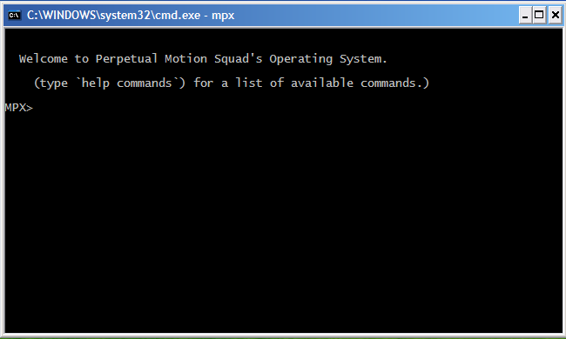
Block-This function is used by typing "block name". Where name is the process you want blocked.
Create-This function is used by typing "create name type priority". Where name is the name of the process, type is 0 for application 1 for system, and priority is a value from -128 to 127.
Date-This function is used by typing "date". It shows detailed information about the current system date. You will then be prompted if you would like to change the date.
Delete-This function is used by typing "delete name". Where name is the name of the process for deletion.
Exit-This command is used by typing "exit". It exits the PMOS after a user prompt.
Help-This shows information about all the functions supported by PMOS.
Load-This function is used by typing "load path". Where path is the directory to search for PMOS files.
Load Process-This function is used by typing "loadProc name fileName priority path" where name is the name you would like to give the process, the fileName is the name of the file to load, the priority is -128 to 127, and path is the location of the file you want to load into memory.
Resume-This function is used by typing "resume name". Where name is the process you want to resume.
Set Priority-This function is used by typing "setPriority name priority". Where name is the process you want to set and priority is from -128 to 127.
Show-This function is used by typing "show name" where name is the name of the function you wish to view info about.
Show All-This function is used by typing "showAll". It shows detailed information about all current processes.
Show Blocked-This function is used by typing "showBlocked". This function shows detailed information about all processes currently in the ready and suspended-ready state.
Show Ready-This function is used by typing "showReady". This function shows detailed information about all process in the ready and suspended-ready states.
Suspend-This function is used by typing "suspend name". Where name is the process you want to suspend.
Terminate-This function is used by typing "terminate name" where name is the process you would like to remove from memory.
Unblock-This function is used by typing "unblock name". Where name is the process you would like unblocked.
Version-This function is used by typing "version". It display detailed information about the current version of PMOS.

